## Key Macro-Economic Concepts

(1) Long-Run, Short-Run and Medium-Run: Are they fixed or context-specific?

(2) Horizontal Aggregate Supply (AS) Curve in the short-term. Prices are sticky

Changes in AD influence employment, output and prices in the short-term. Sometimes, economists say that prices are sticky in the short-term. But, are they sticky only downward? Are they not flexible upward? Firms are willing to rise prices but not cut them.

This assumption enables monetary policymakers to act as though all their actions only influence Aggregate Demand without affecting prices, in the short-term. They assume that supply is infinitely elastic to all macro policies that affect aggregate demand. Supply automatically adjusts to accommodate higher AD induced by macro-economic policies.

Most of the things that conventional economics wants to offer as theories, it assumes them to be true!

(3) In the long run, the AS curve is vertical. What is the practical interpretation of it?

Policies that deal with the business cycle fluctuations cannot influence Aggregate Supply (AS). AS is vertical in the long run. It does not mean that it cannot move from Y0 to Y1 but policies meant to handle business cycle fluctuations cannot do that.

It is defined by the endowment of capital, labour and technology. One can add health, education and the role of women in society to these factors.

(4) **Do we know the true determinants of economic growth?**

It is contextual. History matters. Refer to ’23 things they do not teach you about capitalism’.

Example of East Asia – World Bank Publication in 1993: ‘East Asian Miracle’. **Middle Income Trap. Is East Asia a victim of this?**

The short 5-page note issued by the Federal Reserve Bank of St. Louis mentions physical capital, human capital, better use of capital and labour (productivity) and ‘institutions’ as the ‘ingredients’ of economic growth.[1]

What are ‘institutions’? According to the FRBSL note, it is Property Rights, Competitive Markets and Efficient Financial Institutions.

(5) Factors of production: Land, Labour and Capital

**Definition of Potential Output**: Maximum Sustainable Non-Inflationary Output Possible given current endowments of capital, technology and labour.

Potential Growth Rate: Maximum or Sustainable Rate of non-inflationary growth in GDP, given current endowments.

Slack: Actual output is below Potential Output. Aggregate Demand Policies can work.

Negative Output gap: Actual Growth rate of the economy is below the Potential Growth Rate of the Economy. Aggregate Demand Policies can work.

Positive Output Gap: Opposite of the above. AD may need to be restrained.

What is the potential growth rate in the US, Europe, Japan, Switzerland, China, India and Singapore? Why are they different and within the same country, why do they rise or drop? Example of the U.S. in the 1990s. It went up. Alternatively, crisis (of 2008) permanently damages capacity.

Policymakers infer negative output gap or positive output gap through changes in the inflation rate. IF the rate of inflation is rising (notice that inflation rate itself is the rate of change in the Consumer Price Index), then they infer that the output gap is closed or even positive.

But, inflation rate may not be the only indicator of positive output gap. We will discuss others later.

**(6) Gross Domestic Product**: Note the words, ‘Gross’ (It is not ‘Net’); ‘Domestic’ (does not include foreign) and Product (Production).

**The Macro-economic identity is true by definition:**

Y = C + I + G + (X-M) or NX (Net Exports).

What is measurable is measured. It should have a price. So, goods and services that are not priced but still delivered are not included. Illegal activity not included by definition. GDP is values-free. Quote from Dirk Philipsen’s book: “pill-dependent smoker who, on the way to his divorce lawyer, crashes his oversized car into a school bus because he is texting about an impending derivatives trade.” (<http://www.newyorker.com/business/currency/the-end-of-g-d-p>)

The above identity is GDP by Expenditure. GDP by Income to Factors of Production. See US BEA Quarterly GDP release - Table 9.

[US Trade Balance: went from positive to a four-decade long negative trade balance (deficit). What does it mean? Consuming more than producing. How does one finance it? What is the role of the US dollar in financing the currency? Reserve Currency status. Implications. China’s desire to get into SDR. Why?]

**(7) Savings – Investment Balance and Trade Surplus**

It is important to note that countries that wish to accumulate external surplus (trade surplus and current account surpluses are external surplus) must have excess of savings over investment. In other words, external surplus is reflected in domestic surplus. Remember that Savings are excess of Disposable Income over Consumption. Disposable Income (YD) is Total Income (Y) minus Taxes (TA) plus Transfer Receipts from Government (TR).



One can re-arrange it as follows:



That is, Domestic Surplus (Private Surplus + Government Surplus) = External Surplus. It is an identity.

That is why countries that wanted to boost external surplus did not provide too many avenues for consumption growth. Think of East Asia. They practiced **financial repression**. Financial Repression is about limiting choices for financial savings and putting a ceiling on financial returns for savers so that the government can channelize the savings in desired areas of investment for generating export growth. Compulsory savings through the banking system and regulated interest rates. Restricted avenues for personal spending and financial investments. Lower interest rates also diminish exchange rate attractiveness and help to keep it undervalued.

It also requires keeping wages low to remain competitive in export trade. Hence, most export-oriented nations did not allow active labour unions and collective bargaining rights.

Export-led growth model has advantages. It allows quick catch-up economic growth. It allows scale manufacturing that pure domestic economy does not allow, especially if the size of the country is small. Export-led growth calls for high technology, emphasis on quality, higher education, skilled workforce, etc. These are all positives.

The downside is that an export-led growth model can also result in cronyism with the government favouring the businesses that bring in exports. They may extract concessions (rents) from government. In order to keep exports competitive, they also demanded that the cost of labour be kept in check.

Restrained wage growth does not allow domestic consumption to rise to high levels. It also prevents the emergence of a large and politically powerful middle class. In many Western societies, the middle class has driven political change. The middle class also plays an important role in ensuring pluralism in politics, in society and in culture and in maintaining democratic governance.

To large extent, these developments have either bypassed or have been only partially realised in many East Asian economies that have scaled economic development challenges. In East Asian economies that are aspiring to high-income status, they are mostly absent.

(8) **Nominal and Real GDP**

Remember the definitions. Nominal GDP is the value of goods and services output measured in current prices. Real GDP is current production measured in base year prices.

Why is it important to focus on Nominal GDP growth during deflationary times and Real GDP growth during inflation?

The reason is that we are interested in the growth of output and not just prices. Price change alone won’t be sustainable. Rising prices contributing to higher GDP (nominal GDP growth) means that wages will rise, prices will rise and inflation will pick up. Investment and hiring will slow and economic growth will be affected.

In deflationary times, GDP growth will look better because base year prices are higher than current prices. But, output might have stagnated. Stagnating output means likely falling employment and corporate profits.

Of course, Japan has been experiencing mild deflation and it has not experienced a big rise in unemployment. Why?

The answer could be the demographic shift that has reduced supply of labour. This is one more reminder that there are no standard causes and effects in economics. Circumstances and context-specific facts matter.

Japan’s real GDP growth adjusted for Working Age Population (Age group: 15-64 years) looks ok:

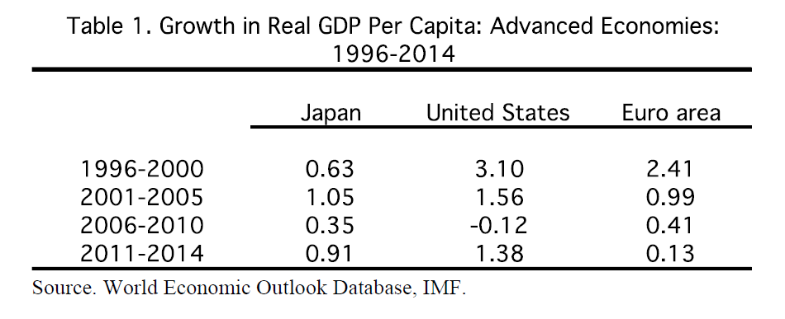

Source: ‘Going bust for growth’, Speech by Dr. Raghuram Rajan, Governor of Reserve Bank of India in New York (May 2015)

However, deflation might be flattering the above picture. Look at their nominal GDP growth per capita (for Working Age Population).



Source: Calculations by V. Anantha Nageswaran for the paper, ‘Is it monetary miracle or mirage in Japan?’ May 2013

This is one reason why Japan has been determined to grow. But, will it succeed? Perhaps, deflation is the right medicine for an ageing society. A society of increasing number of retirees might be happy that their purchasing power is kept intact by falling prices. Quantitative Easing (QE) has weakened their overseas purchasing power since it has weakened the Japanese yen.

But, at the same time, Japanese have a very high Net International Investment Position (IIP). A weaker yen vs. foreign currencies translates foreign assets into higher yen values. Does that make them feel richer and spend more? We do not know. Ultimately, that is an empirical question to be answered with data.

(9) **Anticipated Inflation** can be factored into contracts. Unanticipated inflation is the one that has redistributive effects. It transfers wealth from savers to spenders and from lenders to borrowers. Therefore, the policymakers’ goal is to reduce unanticipated inflation. They have to stabilise inflation expectations. But, recent survey evidence has shown that central bankers have very little role, if any, to play in stabilising inflation expectations. They are shaped by personal shopping experiences and based on few select goods and services. That seems to be as true of households as it is true of firms.

In general, inflation affects all nominal returns. Inflation is the grease that keeps the wheels of economic activity moving forward as we all think in nominal terms. Hence, inflation within reasonable ranges is useful for the economy. Outside of it, it is counterproductive, especially if it is of persistently high inflation or persistent deflation. Japan, we should note, has not had persistent deflation in the last twenty years. See chart below.

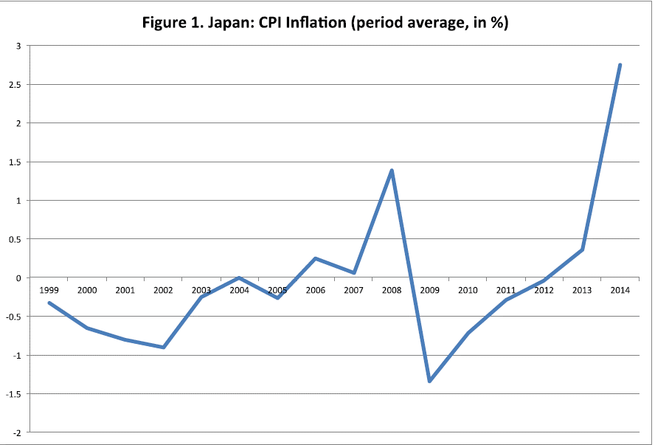

Source: ‘Going bust for growth’, Speech by Dr. Raghuram Rajan, Governor of Reserve Bank of India in New York (May 2015)

(See, for example, Inflation targeting does not anchor inflation expectations: Evidence from firms in New Zealand, BPEA Conference Draft, September 10-11, 2015 - <http://goo.gl/BkLxhk>).

**(10) Nominal vs. Real; Inflation vs. Deflation and Money Illusion**

The rate of change of the Consumer Price Index is only one measure of inflation. By popular usage, it has become the most widely used indicator of inflation. The CPI basket is only a basket of goods and services of the representative household.

US CPI index has gone up by nearly 8 times in the last fifty to sixty years. Is Inflation inherently bad? No.

Given human nature which is comfortable thinking only in nominal terms, some nominal annual increase is inevitable. Further, governments can only tax nominal dollars and not dollars ‘gained’ through deflation. Employers too prefer inflation. Only then, can real wages become flexible – go up or down. Easy to ‘cheat’ workers through lower or even negative real wage growth when inflation is positive (‘Money Illusion’ at work).[2] Without inflation, real wages become cannot be brought down except through a big nominal wage decline. That may not be acceptable and may be economically and socially disruptive.

*In fact, the well-known construct in modern macro-economics is the Philips Curve. The Philips Curve posits the trade-off between inflation and unemployment. William Phillips, a New Zealand born economist, wrote a paper in 1958 titled The Relation between Unemployment and the Rate of Change of Money Wage Rates in the United Kingdom, 1861-1957, which was published in the quarterly journal* ***Economica****. In the paper Phillips describes how he observed an inverse relationship between money wage changes and unemployment in the British economy over the period examined. Similar patterns were found in other countries and, in 1960, Paul Samuelson and Robert Solow took Phillips' work and made explicit the link between inflation and unemployment: when inflation was high, unemployment was low, and vice versa.* [Source: Wikipedia]

Milton Friedman wrote that there was no long-run trade-off between inflation and unemployment. In other words, he wrote that there couldn’t be a permanently lower unemployment rate by having a permanently higher inflation rate. This lovely little parable illustrates that very well.

***THE PARABLE OF THE LONG RUN PHILLIPS CURVE***

*The kingdom of* ***Friedmanium*** *was so small that it had only two producers, a baker and a tailor. The kingdom had a central bank and the central bank governor had to do whatever the king ordered. One day, to meet the expenses of the state, the king instructed her to print plenty of currency notes which were distributed to the government officials. The officers gleefully started spending more on bread and clothes.*

*The baker was thrilled to find more bread being purchased and she increased the price of a loaf from Rs. 10 to Rs 20 since she found that people were willing to pay the higher price. To meet the additional demand she increased the production of bread. The workers gladly put in more hours of work since their wages were hiked. More workers were also employed to expand output.*

*After a month or so the baker and her workers, delighted by their additional earnings, decided to celebrate by purchasing some new clothes ... only to realise that, just like the price of bread, the price of clothes had also increased! After all, the officials who spent more on bread also increased their spending on clothes and the tailor hiked the prices of garments.*

*The baker and her workers found that, while they were earning more Rupees, those additional rupees were worth less than before since the price of clothes had increased. Likewise, the tailor and her workers found that while their handbags were carrying more Rupees since more clothes were being bought at higher prices, they could not purchase more bread with those additional rupees since bread had become costlier.*

*The workers in the bakery and the tailoring jointly reduced their working hours since they realised that they were putting in more hours wrongly thinking the higher wages enabled them to buy more stuff. The baker and the tailor realised it was not worth producing more than what they were producing earlier and so they told their newly employed workers they were not needed any more.*

*A year later, the king got more currency notes printed. The baker and the tailor remembered what happened the last time when there was an increase in the currency notes. So this time around, as the officers went about buying more stuff, only the prices went up; the baker did not bake more loafs and the tailor did not make more clothes, even temporarily. Of course, this also meant they did not employ more workers, even temporarily.*

*The central bank governor was the only person thrilled now. For at long last the king understood that printing currency notes to expand output of clothes and bread and to reduce unemployment works only in the short term . In the long-term output and unemployment will be unchanged and only the prices will go up. Not a happy prospect, no?*

Hence, some moderate inflation is useful to all. Similarly, moderate deflation need not result in economic depression. Empirically, there is no association between economic contraction and depression with deflation except in the 1930s. Most deflationary episodes have been due to productivity improvements or advent of technology. Purchasing power of households improves in deflationary times.

Remember that instead of making theoretical arguments, in economics, one must proceed from reality to theory. Or, in other words, from data to theory.

**(11) Inflation indexation of wages**

Indexing wages and other payments against inflation is an inflation hedge. The aim is to protect real returns. But, wage indexation also affects real wage flexibility. If real wages are inflexible downward, it is a disincentive for employers. They cannot reduce wage costs in a downturn. Second, if real wages do not decline in downturn, then it won’t incentivise re-hiring. Unemployment may remain stubborn.

In the case of a demand shock that raises prices, wage indexation won’t be a problem for enterprises. Their revenues will rise with prices and hence wage increases can be accommodated.

If a supply shock leads to loss of production and sales but not prices (more like a stagflation situation), real wages have to fall but wage indexation may prevent that from happening.

The question to ask is whether Europe – even though there is no formal indexation – has real wage flexibility as much as the United States. Perhaps not. Otherwise, the structural unemployment may not be so high there.

Whether it is low-wage jobs or high-wage jobs, the United States has created jobs since the crisis far better than Europe has.

Another interesting question is whether paying minimum wages will deter employment or hiring or not. Ultimately, the answer has to be found in empirical verification. It need not deter hiring as long as enterprises can still make profits. If living wages are not paid, workers will not make themselves available. Supply of labour will shrink. Further, capitalism has to be based on a bedrock of fairness, ethics and morality.

Last January, seven Nobel Laureates in the United States [**signed**](http://www.bloomberg.com/news/articles/2014-01-14/seven-noble-laureates-urge-increase-in-u-s-worker-minimum-wage) the letter on Minimum wages.

**(12) Whether policymakers fight inflation or boost employment is also an ideological choice.**

Since most of the cost of production is wages, controlling inflation amounts to restraining wages. Thus, the policy orientation towards controlling inflation that began in the 1980s has to be seen in that context of the shift from pro-labour, pro-worker orientation post-WW II to a pro-capital stance. It coincided with or brought about the advent of Mrs. Thatcher and Mr. Reagan in the UK and in the USA respectively. We will also learn later in the course about the onset of financial liberalization that began around this time.

Also, remember the discussion on the widespread introduction and use of mathematics in the 1970s. It was motivated by the desire to get the government to adopt ‘laissez faire’ or ‘market knows best’ policies. That was also part of the ideological shift towards Capital from Labour. For that, the assumption of rational economic agent became necessary. Also, it had to be shown that this was superior to government intervention. In other words, the ideological agenda had to be camouflaged. The superficial purpose had to be seen as the pursuit of superior economic outcomes and not an ideological shift towards Capital away from Labour.

For that, the use of elegant and ‘superior’, self-calibrating mathematical models had to be invoked. That, left to themselves, economic policies can be ‘programmed’ to deliver deterministic results like in the case of physical sciences, even though counterfactual scenarios cannot be constructed or controlled experiments cannot be done in economics, in social sciences and in real life!

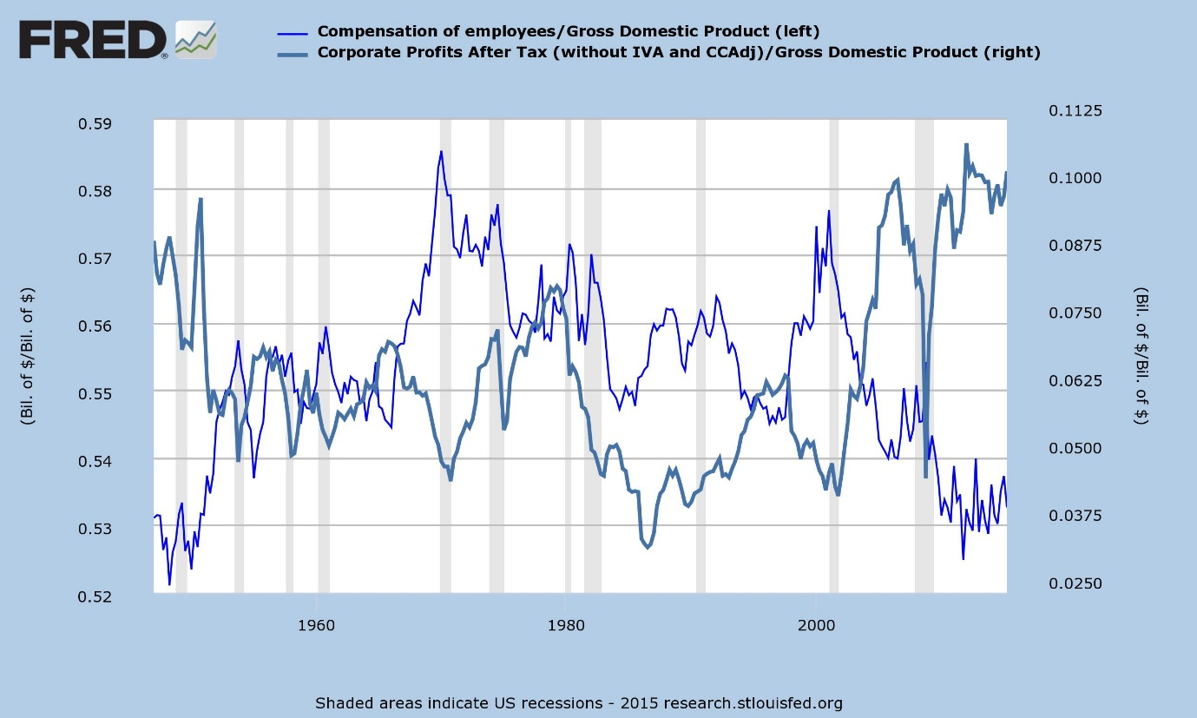

US Labour Compensation and Corporate Profits Shares of GDP.

Source: FRED Database of the Federal Reserve Bank of St. Louis

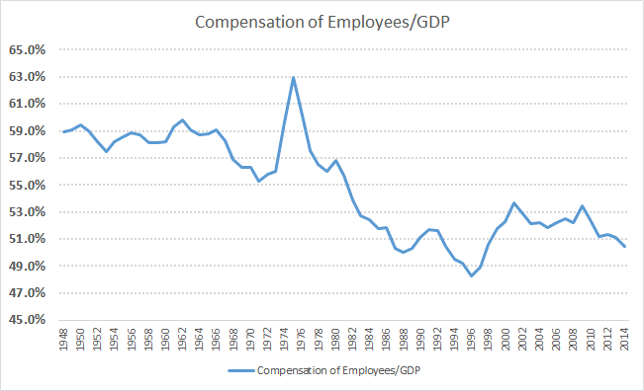

UK Compensation of Employees/GDP.

Source: Office of National Statistics, UK

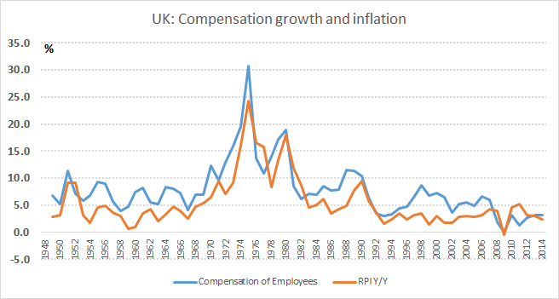

UK: Growth in Compensation Costs and Retail Price Index Inflation

Source: Office of National Statistics

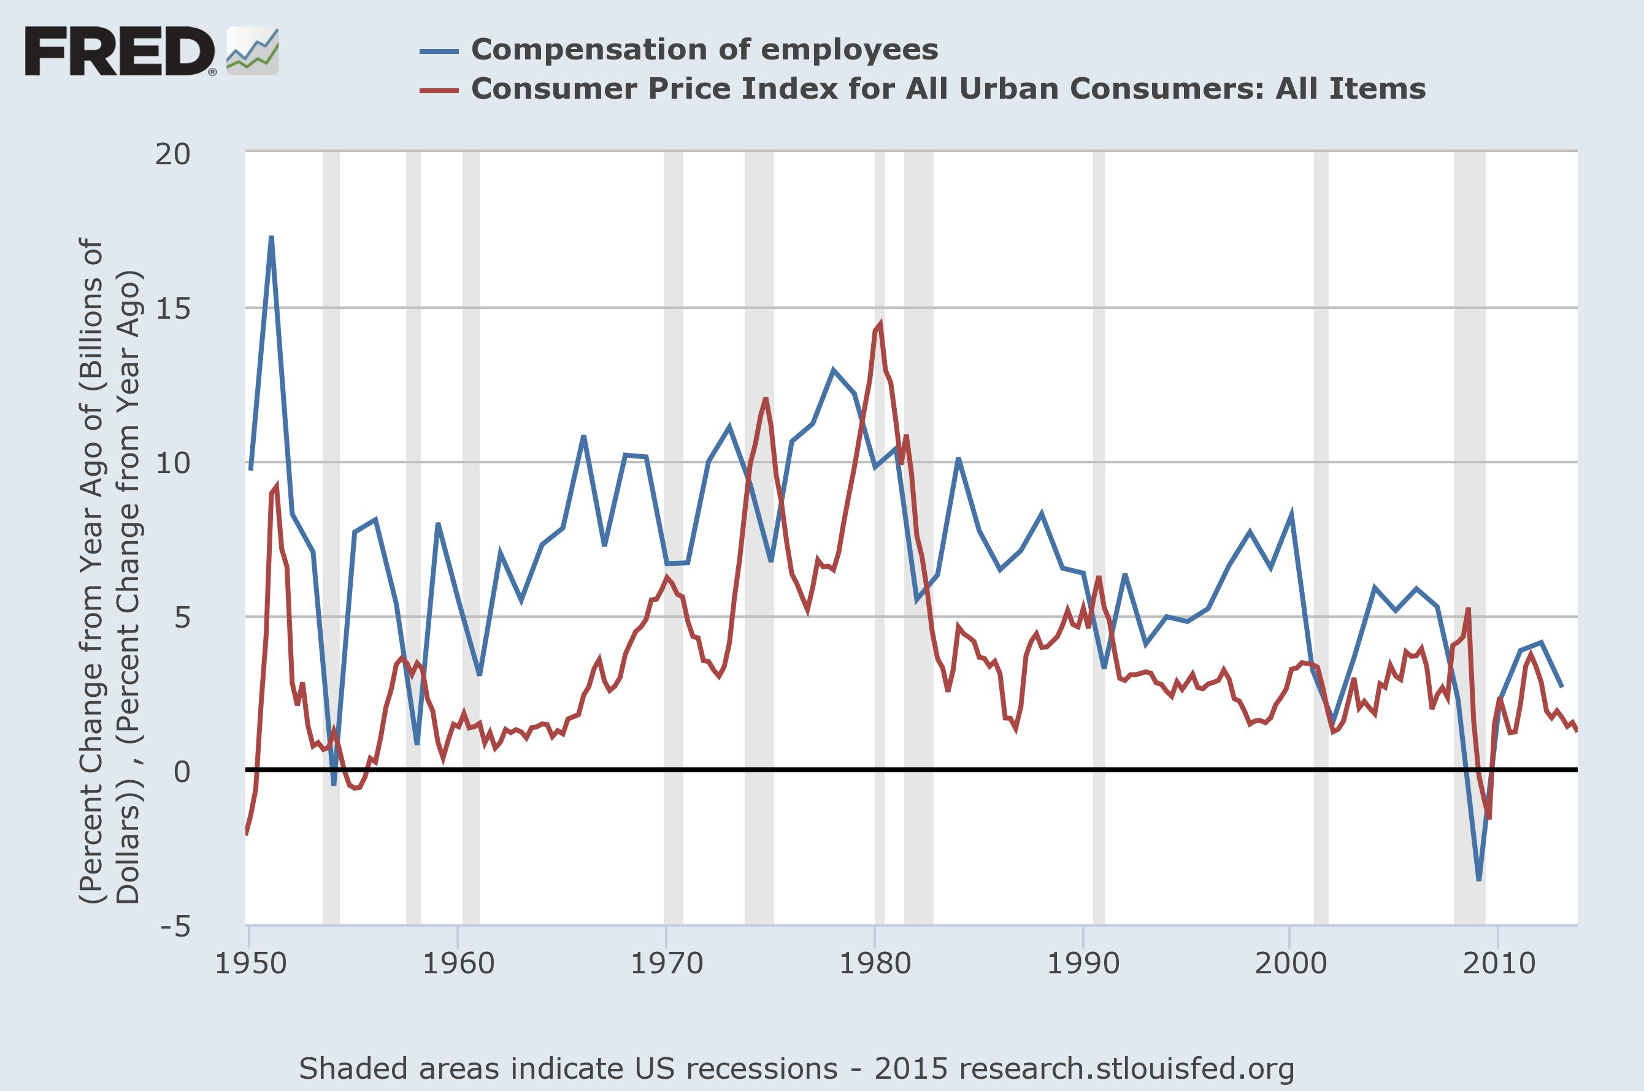

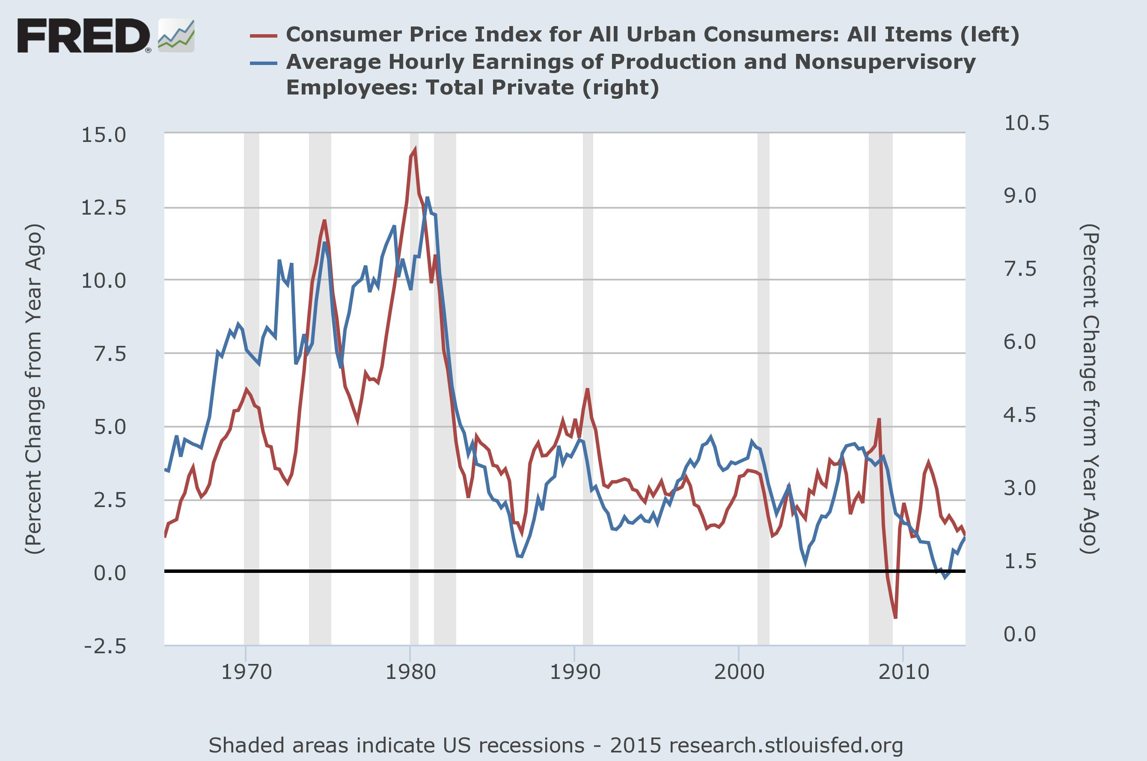

**13. Monetary Policy**

Monetary policy deals with money – either with the quantity of money (Money Supply) or with the price of money (interest rates). Central bankers try to manage business cycle fluctuations around the trend through the deployment of monetary policy. Monetary policy does not claim to deal with Aggregate Supply (AS) issues. However, the dividing line can be a bit vague. To the extent that monetary policy deals with Aggregate Demand (AD) and investments in physical assets are a part of it, a rise in investment spending can shift long run AS curve to the right. Good investments – investments that elevate the productive potential of the economy – raise the potential output of the economy. Bad investments – unproductive investments – do the opposite especially because they will have eaten up available capital that could have been invested in assets that are more productive.

Central banks, whether officially or not, are trying to determine their policy rate through their judgement and estimation of the real rate of interest, the potential growth rate of the economy, the actual growth rate, the inflation target (official or informal) and the actual inflation rate. Whether they focus equally or more or less on output as they focus on inflation depends on the weights they assign to α and β in the equation below. α and β will sum to 1 in the equation below.



α = 1 means that the central bank is an inflation-targeting central bank. β = 1 means that the central bank focuses on stabilising output.

Central Banks think that their monetary policy acts through asset prices. By raising or lowering the opportunity cost of keeping money in a checking account, they think that they will persuade people to invest in higher yielding assets or by shifting to cash, alternately. When they reduce interest rates, they raise the opportunity cost of keeping money in the bank. The opposite happens when they raise interest rates.

The problem is that the transmission from asset price to the real economy remains a big question mark. Ultimately, their goals are output, employment and inflation. Rising asset prices may not lead to good investments and employment. Rising asset prices create bubbles. To the extent that interest rates act primarily on financial assets, they may benefit a small segment of the population that owns financial assets. The transmission from financial asset prices to higher economic growth via Investment has not been fully established. In fact, a survey of Chief Financial Officers (CFO) in the US showed that they do not bring down their hurdle rates when central banks cut rates and boost investment. Their hurdle rates for investment remain unchanged for a long time.[3] European Central Bank is discovering the same. Hence, there is good reason to suspect that the transmission from lower yields to higher capital expenditure is strong on paper and weak in practice.

But, there is some evidence that rising home prices boosted household consumption. It is debatable if that is either healthy or sustainable economic growth, as the crisis of 2008 proved not just for the United States but for many countries.

Moreover, another problem that central banks have not addressed is that they intervene through asset markets only when asset prices are down and not when they are high or too high. That is, they try to boost risk-taking in the economy by boosting asset prices. But, when they wish to dampen animal spirits, they do not act to curb exuberance in asset markets. That gives rise to questions as to whether their target of intervention is asset markets itself and not the real economy.

Over the last two decades, Central Banks, particularly in the West and led by the United States, have sworn by predictability, transparency and avoidance of policy surprises. William White, formerly of the Bank for International Settlements had this to say on transparency and predictability:

*Well I have had fundamental doubts about the merits of full transparency for at least a decade. Moreover, I’ve never spoken to a market person who’s disagreed with me. Transparency on the part of a central bank has disadvantages as well as benefits. We at the BIS first started reflecting on this issue around 2004 when the Fed started talking about “measured” increases in interest rates, which was code for 25 basis points per meeting. If you think about a Sharpe ratio, where the differential between the borrowing rate and the lending rate are going down, but the variance is basically going to zero, then transparency of this sort is really an invitation to take on leverage and that is precisely what people did. And I think it’s the kind of stuff they’re doing today.*

*I go back to my early days of the Bank of Canada when we brought in inflation targeting, about three months after New Zealand. Subsequently, and only gradually, the mantra of transparency became more fully firmly embedded. And I can remember talking to John Crow who as then the Governor and saying to him that it was a huge step to go from “Trust me to do the right thing” to “Now I am going to tell you what I intend to do in the future”. Moreover, I remember saying to him I did not recall ever having a discussion of this issue at the Bank of Canada. We just morphed into it. Basically, I think it had its roots in all the academic stuff about economic agents having rational expectations. And that assumption too is, I think, fundamentally flawed.*

Source: William White in [interview](http://www.cobdencentre.org/2015/03/interview-with-dr-william-white-former-head-of-the-monetary-and-economic-department-at-the-bis/) with Sean Corrigan

According to Jim Grant, on predictability and avoiding volatility, Charles Goodhart, who served on the Monetary Policy Committee of the Bank of England had this to say on the usefulness of volatility:

*“In the pre-Fed days with which the history deals, the call money rate dove and soared. There was no stability—and a good thing. In a society predisposed to speculate, as America was and is, he writes, unpredictable spikes in borrowing rates kept the players more or less honest. “On the basis of its record,” he writes of the Second Federal Reserve District before there was a Federal Reserve, “the financial system as constituted in the years 1900-1913 must be considered successful to an extent rarely equaled in the United States.”*

Source: Jim Grant cites Charles Goodhart from his book, ‘The New York Money Market and the Finance of Trade, 1900-1913’, from the speech delivered by Jim Grant at the Federal Reserve Bank of New York (12th March 2012)

<http://www.zerohedge.com/news/must-read-jim-grant-crucifies-fed-explains-why-gold-standard-best-option>

In all, there are concerns that central banks in the developed world, particularly the Federal Reserve, might have lost sight of their real economy goals and may be focusing on asset markets as ends in themselves. That may make them popular on Wall Street but they may not be helping the man and the woman on the Main Street.

**Does monetary policy influence expectations?**

If the impact of central bank actions on real output (economic growth) is not clear-cut, what about their effectiveness on inflation and inflation expectations? A paper[4] presented at a recent conference in the Brookings Institution had blown a big hole through the dominant paradigm on central banks and their role in inflation management. This paper presented evidence from surveys of inflation expectations and understanding of inflation conducted among firms in New Zealand. The participants had a good understanding of what inflation was about and did not have any suspicion of official data on inflation. Yet, they formed their inflation expectations based on their personal shopping experience and based on the price of gasoline. Only a small portion seemed aware of the Reserve Bank of New Zealand, its inflation target, etc. The evidence was a damning indictment of the role of central banks in anchoring inflation expectations. Rather, it confirmed their non-role. Surveys in the United States confirmed these results found in New Zealand.

**Where does this take us on monetary policy?**

Not very far, I am afraid. Its ability to boost investment, output and employment seems to require the willingness to borrow and invest at lower prices. When confidence is low, no amount of cheap money persuades enterprises to invest. Monetary policy actions influence asset prices, surely. But, the transmission from asset prices to the real economy is missing. Further, central banks have been mostly willing to act on asset prices only when they are low and not when they are high. They seem reluctant to court unpopularity. But, then that is why unelected (and, hence unaccountable) technocrats are appointed for the job. They are not supposed to court popularity. They do not seem to have much of an influence on inflation expectations although they may claim that without their inflation-targeting mandate, inflation expectations could be even more unanchored, unstable and higher. There is no way of knowing this.

A recent [speech](http://www.rbnz.govt.nz/research-and-publications/speeches/2015/speech2015-10-14) (14th October 2015) by Graeme Wheeler, the Governor of the Reserve Bank of New Zealand, provides the most succinct summary of the limitations of central banks.

***Monetary policy in a small open economy***

*Central bankers also operate in a world where there is widespread overestimation and misunderstanding of what monetary policy can deliver. I will elaborate on three areas that may contribute to this. These concern the scope of monetary policy; the dynamics – notably in terms of transaction volumes, driving forces and time horizons — of financial markets and their interaction with monetary policy; and the degree of precision of the links between policy actions and outcomes.*

***Scope of influence***

*Flexible inflation targeting here and overseas has been successful over the last 25 years in reducing inflation to low and stable levels – the best contribution monetary policy can make to an economy’s long-run growth. Over the shorter term, monetary policy stabilises inflation by countering fluctuations in demand growth and employment away from their longer-run trends.[5] With inflation expectations stabilised at low levels, and the associated gain in policy credibility, the ability of monetary policy to help counter short-run fluctuations in output and employment has increased.*

*Monetary policy is, however, relatively powerless to influence the decisions that determine long-run economic performance and distributional outcomes. For example, over the long run, monetary policy can do little to generate higher spending by households and firms. Even in the shorter term, monetary policy’s influence may be low in an environment where debt levels are high and where there is considerable uncertainty about economic prospects.*

*Monetary policy can influence risk-taking in asset markets, but this does not necessarily translate into risk taking in long term real assets – requiring the investment and entrepreneurial decisions that underpin productivity growth and hence long-run improvements in living standards. Monetary policy also can’t prevent international developments from affecting our economy, including through commodity prices and the exchange rate. In this regard, there is little that monetary policy can do to persistently lower an exchange rate, whether through the choice of exchange rate regime or direct policy actions.*

*Similarly, the Reserve Bank is unable to influence long-term real interest rates. These are affected by a range of factors, including global savings and investment flows, risk premia and expectations for economic growth and inflation. Monetary policy can only influence short-term interest rates and, over the medium term, actual and expected rates of inflation.*

Hence, what is clear is that the importance and the efficacy of monetary policy is vastly overstated. The attention given them by financial markets is disproportionately large. But, then, given that central banks keep the interests of financial markets foremost in their calculations, who can blame them?

1. See here: https://research.stlouisfed.org/publications/page1-econ/2013/09/01/what-are-the-ingredients-for-economic-growth/
2. The Wikipedia entry on ‘Money Illusion’ is interesting and recommended (<https://en.wikipedia.org/wiki/Money_illusion>)
3. Steven A. Sharpe and Gustavo A. Suarez: ‘The insensitivity of investment to interest rates: Evidence from a survey of CFOs’, Finance and Economics Discussion Series, Divisions of Research & Statistics and Monetary Affairs, Federal Reserve Board, Washington, D.C. December 3, 2013 (<http://www.federalreserve.gov/pubs/feds/2014/201402/201402pap.pdf>)

   Chris Bryant and Claire Jones: ‘ECB quantitative easing: Failure to spark’, Financial Times September 7, 2013 (<http://www.ft.com/intl/cms/s/0/619b139c-3ce4-11e5-8613-07d16aad2152.html>)
4. Saten Kumar, Hassan Afrouzi, Olivier Coibion and Yuriy Gorodnichenko: Inflation targeting does not anchor inflation expectations: Evidence from firms in New Zealand, BPEA Conference Draft, September 10-11, 2015 (https://brook.gs/3hzbZk5).